

**Student ID: BC220401569**

**Name: Zubair Ahmed**

**Assignment # : CS301 ( 2 )**

**Question no 1**

**Consider the following string saved into a string type variable. We want to send it over the network to another computer. Use the given string and answer (solve) the questions given below.**

**( a ) Build frequency table and Huffman encoding tree.**

**Solution:**

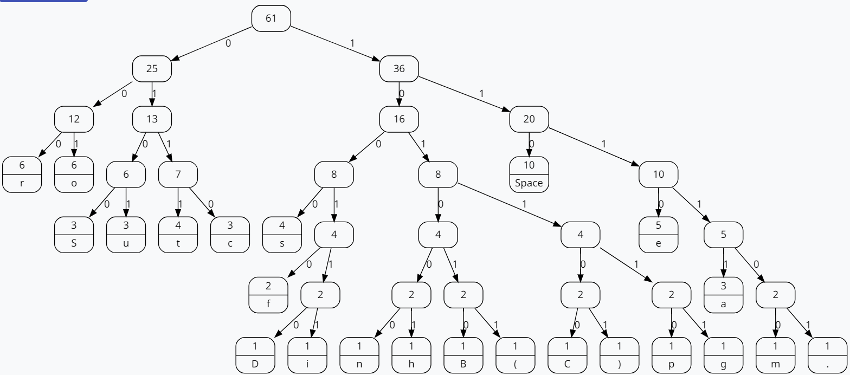

**Use the following sample frequency table:**

| **Character** | D | a | t | space | S | r | u | c | e | i | s | o | n | f | h | B | ( | C | ) | p | g | m | . |
| --- | --- | --- | --- | --- | --- | --- | --- | --- | --- | --- | --- | --- | --- | --- | --- | --- | --- | --- | --- | --- | --- | --- | --- |
| **Frequency** | 1 | 3 | 4 | 10 | 3 | 6 | 3 | 3 | 5 | 1 | 4 | 6 | 1 | 2 | 1 | 1 | 1 | 1 | 1 | 1 | 1 | 1 | 1 |
| **Number of Bits used without any encoding** | 8 | 24 | 32 | 80 | 24 | 48 | 24 | 24 | 40 | 8 | 32 | 48 | 8 | 16 | 8 | 8 | 8 | 8 | 8 | 8 | 8 | 8 | 8 |
| **Huffman code of each character** | 100110 | 11111 | 0111 | 110 | 0100 | 000 | 0101 | 01100 | 1110 | 100111 | 1000 | 001 | 101000 | 10010 | 101001 | 101010 | 101011 | 101100 | 101101 | 101110 | 101111 | 111100 | 111101 |
| **Number of Bits used with Huffman encoding** | 6 | 15 | 16 | 30 | 12 | 18 | 12 | 12 | 20 | 6 | 16 | 18 | 6 | 10 | 6 | 6 | 6 | 6 | 6 | 6 | 6 | 6 | 6 |

**( b ) Calculate how many bits will be used for the above string:**

**Without using any encoding technique =** 488

**With Huffman encoding technique =** 251

**Percentage =** 48.56% saved

The End